

**COVID-19 Exposure Guidelines for EMS Providers**

**March 19, 2020**

**Force Protection**

During a known or declared COVID-19 outbreak EMS organizations should consider screening members for symptoms and measuring temperature before allowing members to be on duty. Such screening should be recorded in a log or via electronic means. Members not able to pass the screening criteria should be sent home and asked to self-isolate until symptoms resolve and the provider is afebrile for at least 72 hours.

**Exposure Assessment**

**High-risk exposures** refers to a situation where an EMS provider has had prolonged (> 5 min) close contact with patients with COVID-19 who were not wearing a facemask as a source control measure. Assumes the EMS provider’s nose and mouth were exposed to material potentially infectious with the virus causing COVID-19.  Being present in an enclosed space or the ambulance patient compartment for procedures that generate aerosols or during which respiratory secretions are likely to be poorly controlled (e.g., cardiopulmonary resuscitation, intubation, suctioning, nebulizer therapy, CPAP) on patients with COVID-19 when the healthcare providers’ eyes, nose, or mouth were not protected, is also considered *high-risk*.

**Medium-risk exposures** generally include an EMS Provider who had prolonged close contact with patients with COVID-19 who were wearing a facemask as a source control measure while EMS provider’s nose and mouth were exposed to material potentially infectious with the virus causing COVID-19.  Some low-risk exposures are considered medium-risk depending on the type of care activity performed.  For example, EMS provider who was wearing a gown, gloves, eye protection and a facemask (instead of a respirator) during an aerosol-generating procedure would be considered to have a medium-risk exposure.  If an aerosol-generating procedure had not been performed, they would have been considered low-risk.  See [Table 1](https://www.cdc.gov/coronavirus/2019-ncov/hcp/guidance-risk-assesment-hcp.html#table1) for additional examples.

**Low-risk exposures** generally refer to brief interactions with patients with COVID-19 or prolonged close contact with patients who were wearing a facemask for source control while the EMS provider was wearing a facemask or respirator. Use of eye protection, in addition to a facemask or respirator would further lower the risk of exposure.

**Table 1**

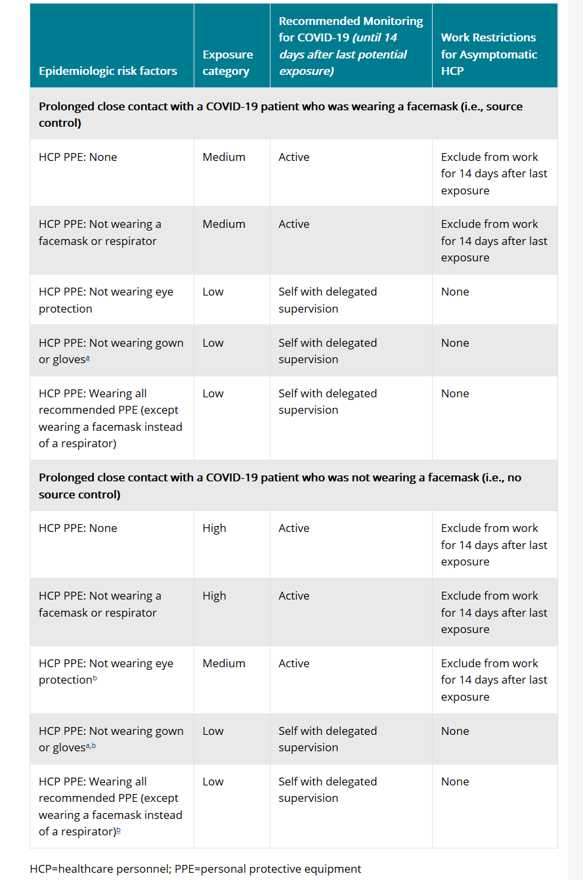

**Post Exposure Recommendations**

**High- and Medium-Risk Exposure Category**

EMS providers in the high- or medium-risk category should undergo active monitoring, for 14 days after their last exposure. Exclusion from work is recommended for at least 7 days post exposure followed by 7 days of wearing a surgical mask in the presence of coworkers, patients and the public.

If the provider is considered essential and they are asymptomatic they may return after 4 days provided a surgical mask is worn in the presence of co-workers, patients or the public for the duration of the 14-day active monitoring period.

If providers develop any fever (measured temperature >100.0°F or subjective fever) OR respiratory symptoms consistent with COVID-19 (e.g., cough, shortness of breath, sore throat)[*](https://www.cdc.gov/coronavirus/2019-ncov/hcp/guidance-risk-assesment-hcp.html#note1) they should immediately self-isolate (separate themselves from others) and notify Gunnison County Public Health and their employer promptly so that they can coordinate consultation, testing and referral to a healthcare provider for further evaluation.

**Low-risk Exposure Category**  
EMS providers in the low-risk category should perform self-monitoring with delegated supervision until 14 days after the last potential exposure.  Asymptomatic EMS providers in this category are not restricted from duty.  They should check their temperature twice daily and remain alert for respiratory symptoms consistent with COVID-19 (e.g., cough, shortness of breath, sore throat)[*](https://www.cdc.gov/coronavirus/2019-ncov/hcp/guidance-risk-assesment-hcp.html#note1). They should ensure they are afebrile and asymptomatic before leaving home and reporting for work. If they do not have fever or respiratory symptoms they may report to work.  If they develop fever (measured temperature > 100.0oF or subjective fever) OR respiratory symptoms they should immediately self-isolate (separate themselves from others) and notify Gunnison County Public Health and their employer promptly so that they can coordinate consultation, testing and referral to a healthcare provider for further evaluation.

**EMS Providers Who Adhere to All Recommended Infection Prevention and Control Practices** Proper adherence to currently recommended infection control practices, including all recommended PPE, should protect the EMS provider from having prolonged close contact with patients infected with COVID-19.  However, to account for any inconsistencies in use or adherence that could result in unrecognized exposures, EMS providers should still perform self-monitoring as described under the low-risk exposure category for the duration of the outbreak.

**Community or travel-associated exposures**  
EMS providers with potential exposures to COVID-19 in community settings, should have their exposure risk assessed according to [CDC guidance](https://www.cdc.gov/coronavirus/2019-ncov/php/risk-assessment.html).  EMS providers should inform their supervisor that they have had a community or travel-associated exposure.  EMS providers who have a community or travel-associated exposure should undergo monitoring as defined by that guidance.  Those who fall into the high- or medium- risk category described there should be excluded from work as described in the high- and medium-risk recommendations above. EMS providers who develop signs or symptoms compatible with COVID-19 should contact their employer and Gunnison County Public Health prior to returning to work.

**No Identifiable risk Exposure Category**  
EMS providers in the no identifiable risk category do not require monitoring or restriction from work.

**Return to work following exposure to confirmedCOVID-19.**

These are guidelines for return to the workforce. Individual cases may require review and specific modification of this plan if there are special circumstances.

**Asymptomatic individual for 14 days following exposure to confirmedCOVID-19.**

If an EMS provider has been asymptomatic for 14 days following COVID-19 exposure, the provider may return to unrestricted duty after confirming monitoring and current status with Health Officer Ashley Akerlund, Gunnison County Public Health. EMS Providers should provide information about the exposure, monitoring and request to return to: (email)

**Symptomatic individual during the 14 days following exposure to confirmed COVID-19.**

The EMS provider may return to duty provided 7 days have elapsed since the onset of symptoms and after they have been afebrile for at least 72 hours following the resolution of their symptoms. Approval to return must be confirmed by Gunnison County Public Health.

Approved By:

________________________________ _____________________________

Joni Reynolds, Public Health Director Shay Krier, EMS Medical Director